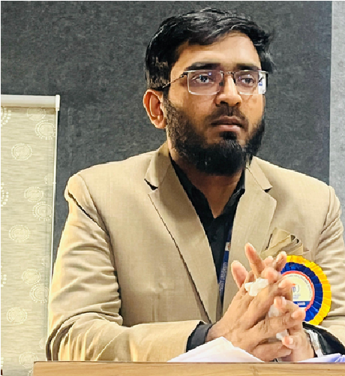
MOHD ARIF UDDIN
Assistant Professor
+91 9652690706 mohammedarifuddin.98@gmail.com

ABOUT ME

M.Pharm graduate and PhD scholar in Pharmaceutical Sciences with experience as an Assistant Professor. Skilled in clinical trial design, clinical data management, pharmacovigilance, and regulatory documentation, with hands-on exposure to GCP guidelines, ethics committee processes, and ICH regulations. With a strong foundation in research methodology and healthcare compliance, and by combining academic and research strengths, I aim to contribute as a Clinical Research Scientist, ensuring patient safety, data integrity, and regulatory compliance.

EDUCATION

2023 - Present PhD in Pharmaceutical Sciences
Datta Meghe Institute of Higher Education and Research
2021 - 2023 Masters in Pharmaceutical Sciences
Sultan ul Uloom College of Pharmacy JNTUH
2017 - 2021 Bachelors in Pharmaceutical Sceinces
Deccan School of Pharmacy OsmaniaUniversity

EXPERIENCE

2023-Present Assistant Professor & Exam Branch Member
Malla Reddy University
2022-2023 Clinical Reserach Intern
Clinosol Pvt Ltd

SKILLS
Analytical method development and validation as per ICH Q2 guidelines
Well-versed in cGMP, GLP, FDA, ICH, USP, EP, and JP guidelines
Analytical documentation, preparation of SOPs, method validation protocols/reports, and regulatory submissions (ANDA/NDA dossiers).
MS Office Expertised (Word, Excel, PowerPoint – for documentation/reporting)

OTHER INFORMATION
Languages Hobies Acheivements Professional Profile
English Reading Article Organising Member for workshop LinkedIn:-
Urdu Planting funded by ICMR Linkedin.com/in/Mohd-
Hindi Volunteering Raised funds and Volunteered in Arif_uddin
Telugu Fitness Activities healthcare/ Social Awareness Prg.
Arabic Cooking Published Research Papers

